UN Datathon

Data set: Food Prices

Q1) What are the prices of the commodities from the year 2010 to 2024?

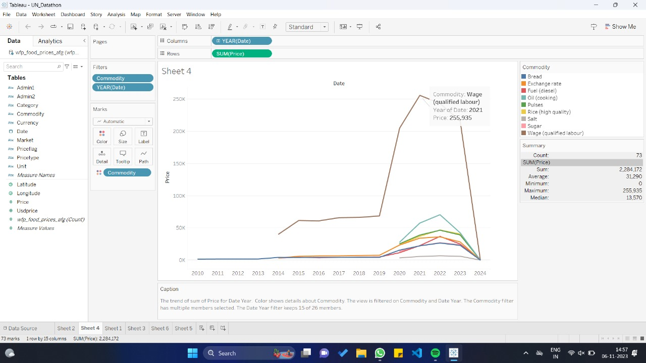

* The Wage (Qualified Labour) is highest in the year 2021 with the price of 255,935 AFN.
* The Wage (Qualified Labour) is lowest in the year 2014 with the price of 40,163 AFN.

Q2) What is the highest count of food price and in which year?

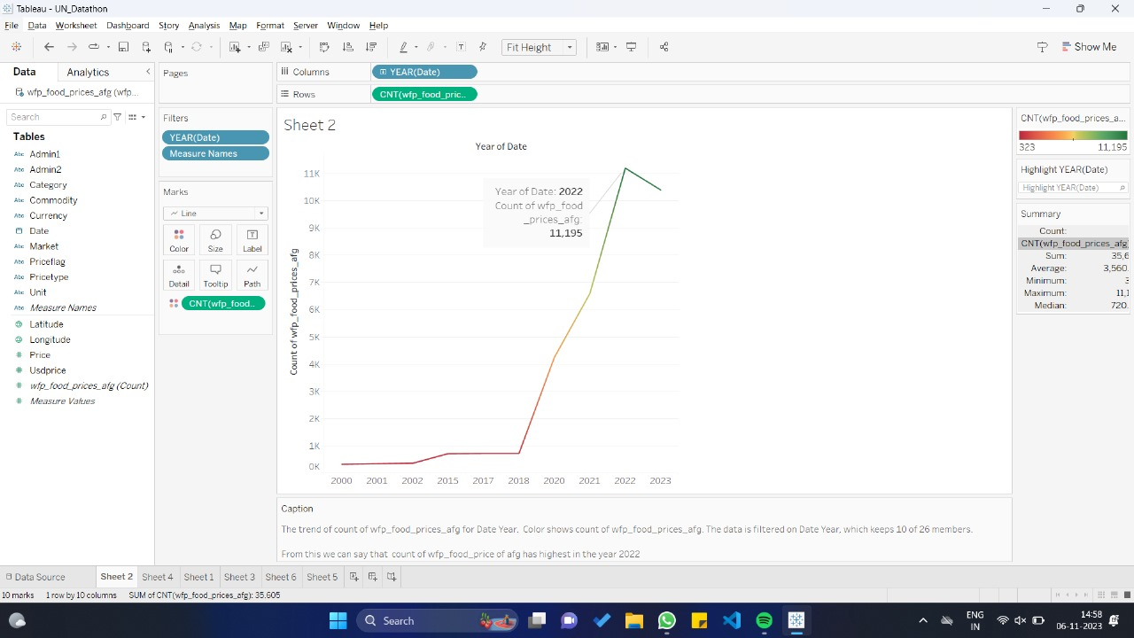

From this graph we can say that count of food price of Afghan has the highest in the year 2022.

Food price of Afghan has the lowest in the year 2000.

Q3) What id the food category which is having highest and lowest price in Afghanistan?

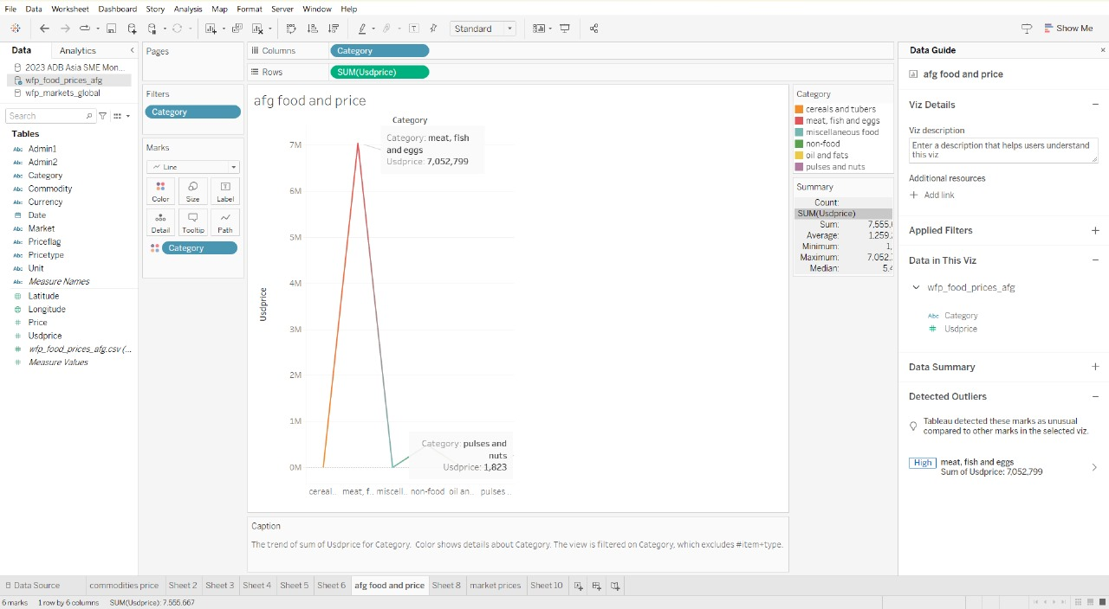

* MEAT, FISH and EGGS is the food category which is having highest price in Afghanistan (usd price: 7,052,799).
* PULSES and NUTS is the food category which is having lowest price in Afghanistan (usd price: 1,823)

Q4) Show the prices of each market in Afghanistan?

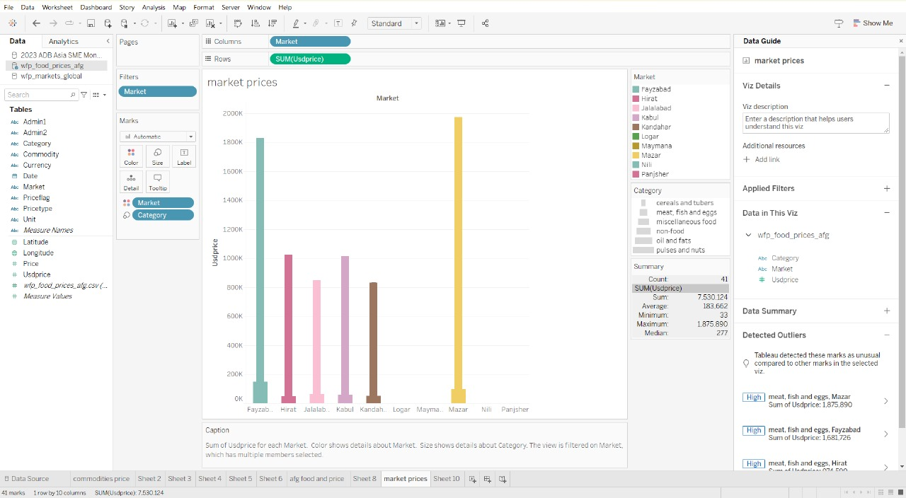

Fayzabad is the market that has highest price in meat, fish and eggs category followed by Mazar and Kabul.

Jalabad is the market that has lowest price in meat, fish and eggs category.

Q5) In Which year fuel (commodity) has the highest price?

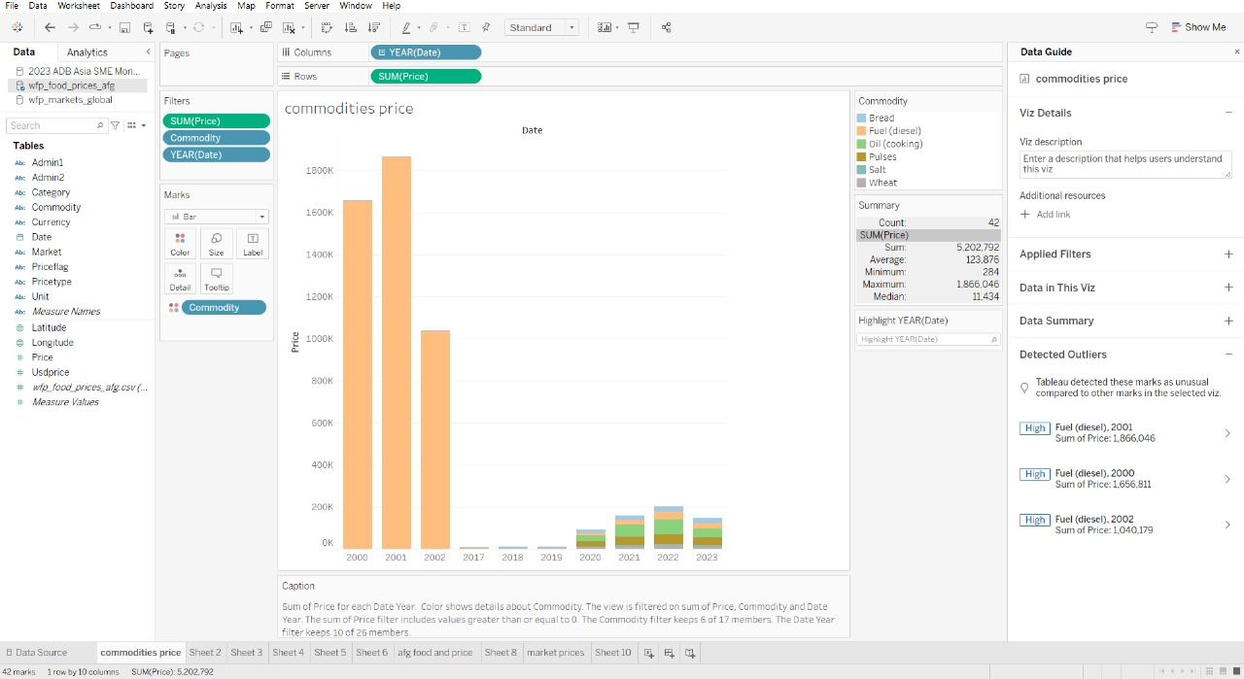

In the year 2001 Fuel (commodity) has the highest price of 1,844,046 AFG followed by the year 2000 and 2002.